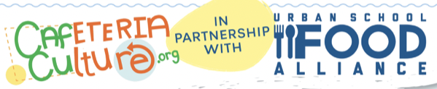 

**Sample Menu for Plastic Free Lunch Day**

* Pizza Choice
* Fresh Broccoli Florets with Dipping Sauce
* Fresh Fruit (Cut Oranges or Whole Bananas preferred)
* Peanut (Sunflower) Butter and Jelly
* Cold Cheese Sandwiches
* Assorted Milk
* Salad Bar* – cucumber slices, cherry tomatoes, green pepper strips, red pepper strips, celery sticks, and carrot sticks

*No individual packaged food items or dressings on the salad bar.

*All standardized recipes followed; the only exception is to wrap items in bulk, using rolls of aluminum foil instead of individually wrapped in plastic.*

**Water Service**

All students must continue to have access to drinking water during meal times. If your school(s) has a refrigerated water jet, share suggested [Morning Announcements](https://drive.google.com/file/d/1HQPq-2hsEPAF881ZCBIhy5Ee587OBeAF/view?usp=sharing) with school administration that encourage students to bring a reusable water bottle: place the [“Ask me if you need a water cup”](https://drive.google.com/file/d/1c4ZQY4MLMRxPQqU_LItibIsP-G8k02qd/view?usp=sharing) [sign](https://drive.google.com/file/d/1c4ZQY4MLMRxPQqU_LItibIsP-G8k02qd/view?usp=sharing) and a recycle bin nearby so discarded cups do not go into the trash.

____________________________________________________________________________

**Tips for success**

* Rather than individually wrapping or packaging items, including fruit, place servings directly on students’ plates.
* Do not wrap items in plastic wrap or food grade bags.
  + If a food item(s) has to be wrapped, use aluminum foil rolls and wrap in bulk instead of foil sheets.
* If your school is offering a salad bar, offer vegetables that students can eat with their hands, like cherry tomatoes or bell pepper strips, rather than leafy greens.
* All vegetables are to be prepared so that they can be eaten with hands.
  + Dipping sauce for the vegetables will be served on the serving line.
  + Extra dipping sauce will be placed on the plate during service - students can dip salad bar vegetables in the same sauce.
* Store cutlery kits or utensils out of sight at the POS and only offer them to students who ask for them.